Experiment: 6
Aim:
To write a Python program to solve the Vacuum Cleaner Problem using a simple reflex agent.
Algorithm:
  - Start the program.
  - Create two rooms, A and B.
  - Mark both rooms as dirty.
  - Place the vacuum cleaner in room A.
  - Check whether the current room is dirty.
  - If dirty, clean the room.
  - Move the vacuum cleaner to the other room.
  - Repeat until both rooms are clean.
  - Display the final room status.
  - Stop.
Code:
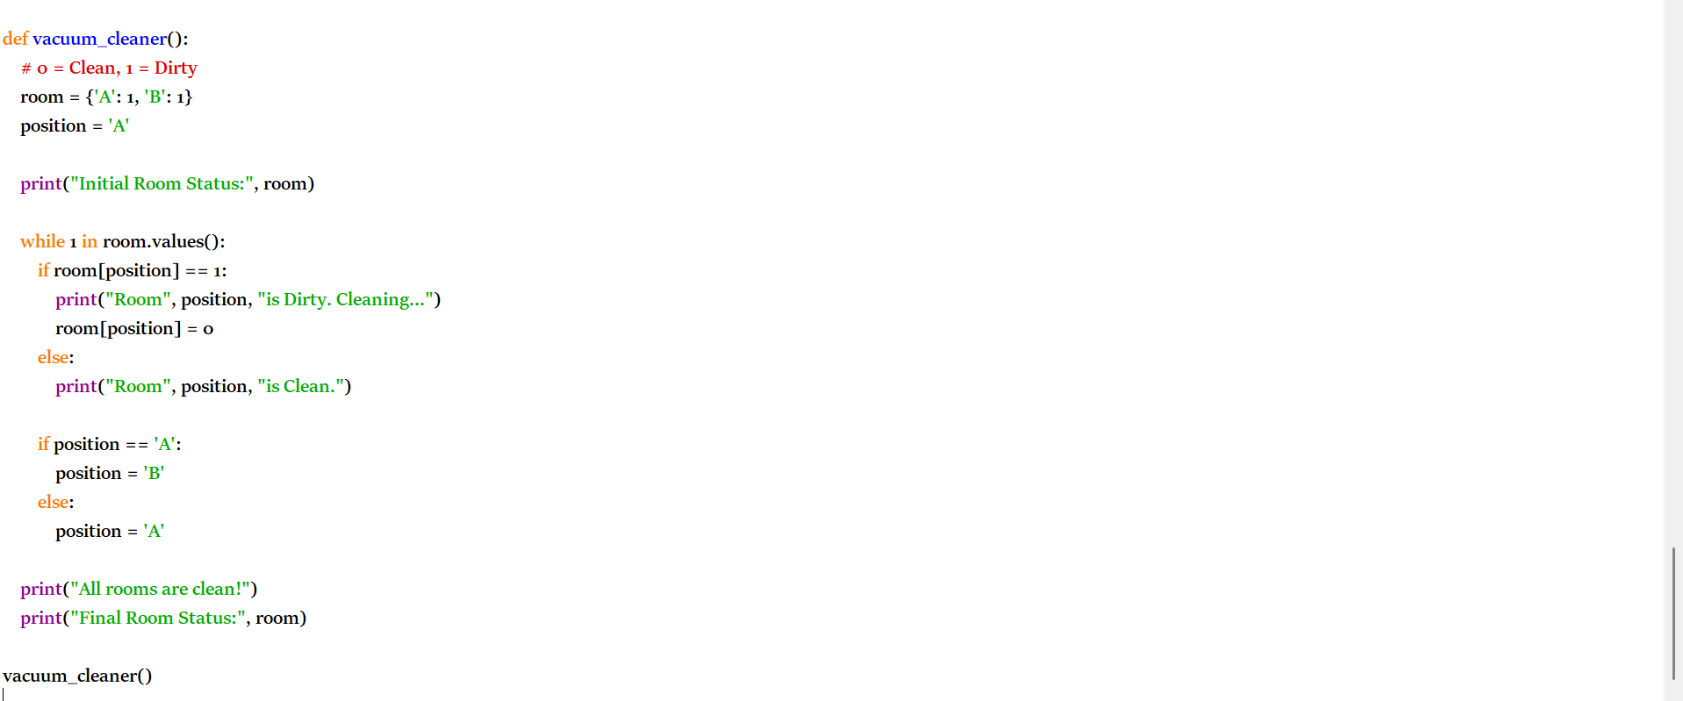
Output: 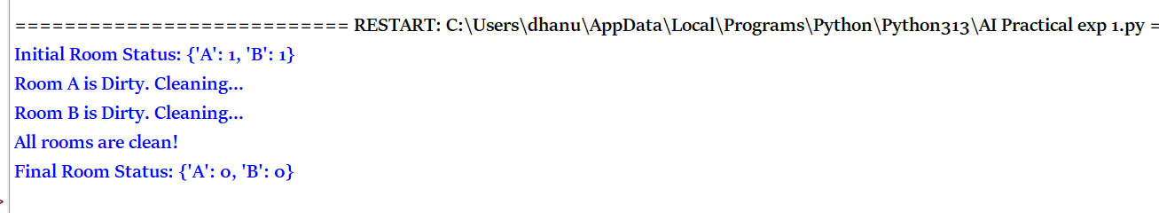

Result:
Thus the python program to solve vacuum cleaner problem is executed and solved successfully.

